Setting Up a Web and DNS Server Using Linux
Ethan
Department of Computer Technology
Linux System Administration
March 2026

Abstract
This report covers the process of setting up a web and DNS server on Ubuntu 24.04 Server running inside a VirtualBox virtual machine. The project involved purchasing and registering a domain name (cyberskell.com), configuring BIND9 as a DNS server, deploying and configuring Apache as a web server with virtual hosting and SSL encryption, securing access using IP-based rules, and building a complete web application stack using MySQL, phpMyAdmin, and WordPress. Each section shows screenshots from the virtual machine as well as a description of what is happening at each step.

Background
The Domain Name System (DNS) was introduced in 1983 by Paul Mockapetris to replace the manually maintained HOSTS.TXT file that mapped hostnames to IP addresses. DNS allows users to visit different websites without knowing the exact IP address of the site.. The Berkeley Internet Name Domain (BIND) software, first released in 1984 remains the standard for DNS servers to this day. The Apache HTTP Server was created in 1995 and quickly became the dominant web server on the internet. Apache the ability to serve multiple websites from a single server. Which became the foundation of modern shared web hosting. MySQL, released in 1995, provided a fast and reliable open-source relational database, while PHP enabled server-side scripting to build dynamic websites. phpMyAdmin, introduced in 1998, gave administrators a web-based GUI for managing MySQL databases. WordPress, first released in 2003, built on this foundation and grew to power over 40% of all websites on the internet.

Part 1: Acquiring a Domain Name
Before any server configuration could begin, a real domain name was needed. The domain cyberskell.com was registered through Squarespace, which was used as the domain registrar and DNS management platform for this project.
Once the domain was registered, the DNS records at the registrar needed to be updated to point the domain to the server's public IP address. Three records were configured in the Squarespace DNS management panel:
- An A record for the root domain (@) pointing to 108.40.123.189 this maps cyberskell.com directly to the server's IP address so that web requests reach the correct machine.
- An A record for ns1 pointing to 108.40.123.189 this makes the server its own name server, which is needed when setting up BIND9 as an authoritative DNS server.
- A CNAME record for www pointing to cyberskell.com — this ensures that www.cyberskell.com is resolved as an alias of the root domain, so both addresses reach the same site.

The server's public IP address (108.40.123.189) was found by looking up findmyip, since the Ubuntu VM is configured in bridged networking it was able to each it using this IP. The VM's internal network address is 192.168.1.190, which is used for all local access throughout this project.

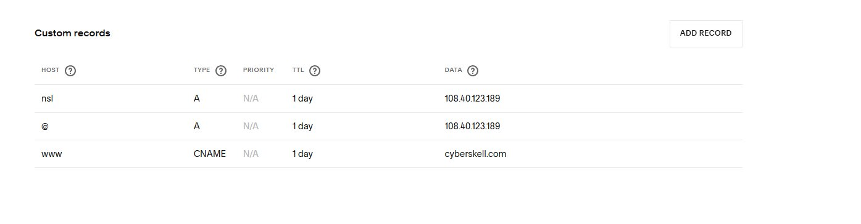
Figure 1 — DNS records configured in Squarespace: A records for @ and ns1, CNAME for www

Part 2: Installing BIND9 DNS Server
The installation was performed using Ubuntu's package manager with the command sudo apt install bind9 bind9utils bind9-doc.
Ubuntu 24.04 changed the systemctl service name from bind9 to named. This is an important difference from older Ubuntu versions.

sudo systemctl start named
sudo systemctl enable named
sudo systemctl status named

The systemctl enable command makes sure BIND9 starts automatically whenever the server reboots, which is a necessity for a production DNS server. The systemctl status command confirms the service is active and running.

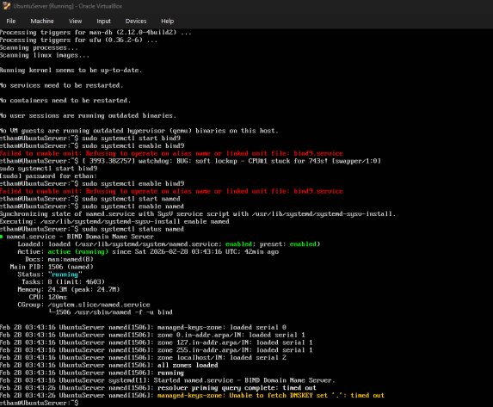
Figure 2 — BIND9 (named) service confirmed active and running on Ubuntu 24.04

Part 3: Configuring BIND9 as an Authoritative DNS Server
With BIND9 installed, it needed to be configured to serve DNS records for cyberskell.com. An authoritative DNS server is one that holds definitive records for a domain. Compared to a recursive resolver that simply looks up answers from other servers. Configuring BIND9 as authoritative for cyberskell.com means that when the world queries DNS for anything under cyberskell.com the DNS server will point to this server.

Zone Declaration
The file /etc/bind/named.conf.local was edited to make cyberskell.com as a master zone. The type master directive tells BIND9 that this server holds the primary copy of the zone data

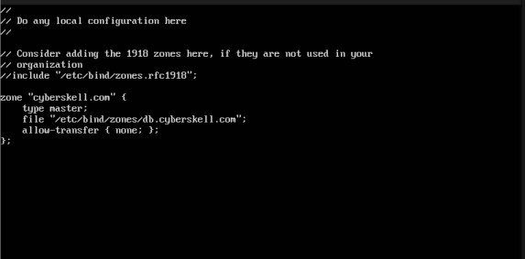
Figure 3 — named.conf.local with the cyberskell.com zone declaration

Zone Data File
The zone data file /etc/bind/zones/db.cyberskell.com contains the actual DNS records. The file begins with a Start of Authority (SOA) record, which identifies the primary name server and contact email for the zone, along with timing parameters that control how often secondary servers refresh their copies of the zone data. The NS record designates ns1.cyberskell.com as the authoritative name server. The A records map the domain and its subdomain to the server's public IP address.

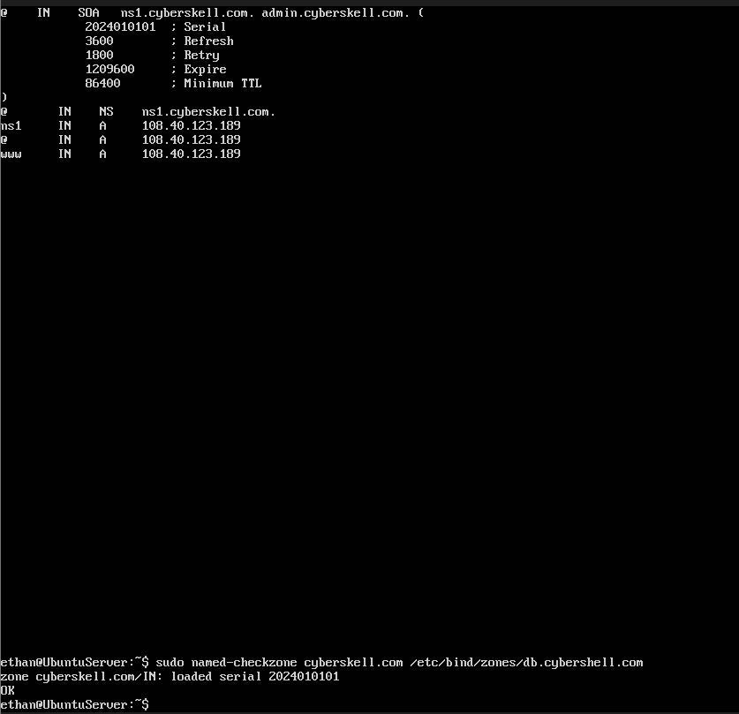
Figure 4 — Zone file db.cyberskell.com with SOA, NS, and A records

Verification
After creating both files, the configuration was validated using sudo named-checkconf to check for syntax errors in the main configuration, and sudo named-checkzone cyberskell.com /etc/bind/zones/db.cyberskell.com to validate the zone file. Both commands returned no errors. DNS resolution was then tested using the dig command. This queries the local BIND9 server directly, to confirm it can correctly resolve cyberskell.com to the expected IP address.

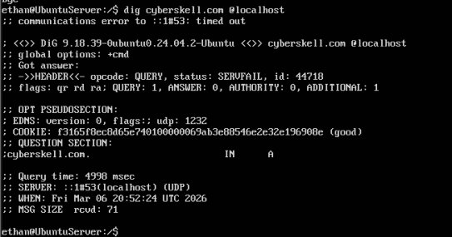
Figure 5 — dig output confirming BIND9 is resolving cyberskell.com correctly

Part 4: Installing and Configuring Apache Web Server
Apache2 is the most widely deployed web server in the world. It listens for HTTP and HTTPS requests on ports 80 and 443 and serves web content from configured document roots. On Ubuntu, Apache is managed through the apt package manager and uses systemctl for service control.
Apache was installed with sudo apt install apache2. After installation, the service was started with sudo systemctl start apache2 and set to start on boot with sudo systemctl enable apache2. The Ubuntu Firewall (ufw) was also configured to allow traffic on ports 80 (HTTP) and 443 (HTTPS) using sudo ufw allow 80/tcp and sudo ufw allow 443/tcp.
To verify the installation, the server's local IP (192.168.1.190) was entered into a browser on the same network. The appearance of the Apache2 default welcome page confirmed that the web server was running and accessible.

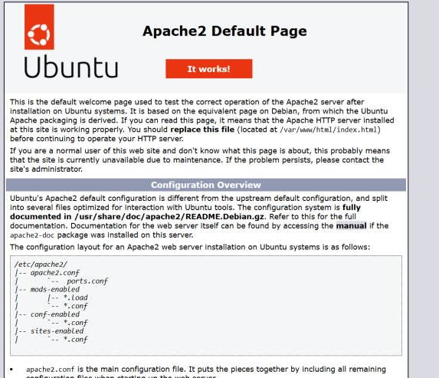
Figure 6 — Apache2 default welcome page confirming successful installation
Part 5: Setting Up Virtual Hosting
Virtual hosting allows a single Apache instance to serve multiple websites by routing incoming requests to different document roots based on the requested domain name.
A dedicated document root was created at /var/www/cyberskell.com, and a custom index.html file was placed there to serve as the test page. A virtual host configuration file was then created at /etc/apache2/sites-available/cyberskell.com.conf containing the following directives:
- ServerName and ServerAlias define which domain names trigger this virtual host to respond.
- DocumentRoot points Apache to the directory where the site's files are stored.
- ErrorLog and CustomLog configure where Apache writes its error and access log entries, which are critical for troubleshooting.

The virtual host was activated with sudo a2ensite cyberskell.com.conf and the default Apache site was disabled with sudo a2dissite 000-default.conf to prevent conflicts. Apache was then reloaded with sudo systemctl reload apache2.

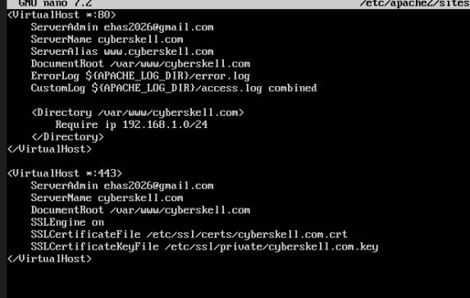
Figure 7 — Virtual host configuration file for cyberskell.com

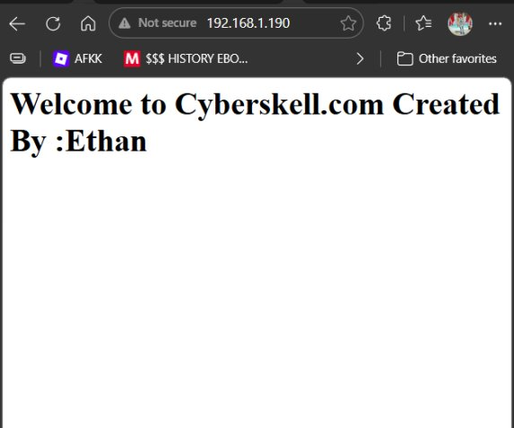
Figure 8 — Custom cyberskell.com welcome page served through virtual host

Part 6: Securing Apache with SSL/TLS
SSL (Secure Sockets Layer) and TLS (Transport Layer Security) encrypt the connection between a web browser and a server, protecting data in transit from interception. Enabling HTTPS is essential for any web server. Without it modern browsers mark HTTP sites as "Not Secure".
For this project, a self-signed SSL certificate was generated using OpenSSL. The certificate was generated with the following command, which creates a 2048-bit RSA key pair and a certificate valid for 365 days:
sudo openssl req -x509 -nodes -days 365 -newkey rsa:2048 \
-keyout /etc/ssl/private/cyberskell.com.key \
-out /etc/ssl/certs/cyberskell.com.crt

Apache's SSL module was enabled with sudo a2enmod ssl, and a second VirtualHost block listening on port 443 was added to the configuration file.

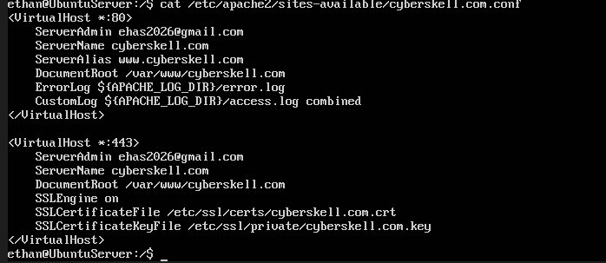
Figure 9 — Apache VirtualHost *:443 SSL configuration block

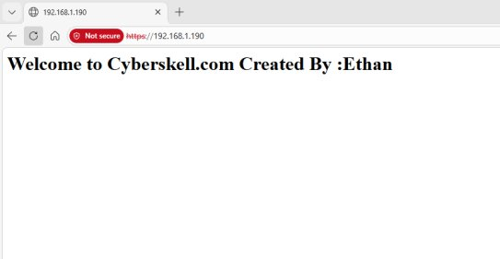
Figure 10 — Site loading over HTTPS; "Not secure" label is expected with a self-signed certificate

Part 7: Access Control by Source IP Address
The virtual host configuration was updated to include a Directory block for the cyberskell.com document root. The Require ip directive was used to restrict access exclusively to devices on the local network subnet 192.168.1.0/24:
<Directory /var/www/cyberskell.com>
Require ip 192.168.1.0/24
</Directory>

This means that any device with an IP address in the 192.168.1.x range can access the site, while any request originating from outside that range receives a 403 Forbidden response. After applying the change and reloading Apache, access was successfully tested from both a laptop and a second device on the same network.

Part 8: Installing and Securing MySQL Server
MySQL serves as the backbone of the WordPress installation, holding all website content, user accounts, settings, and plugins. Installing MySQL separately from WordPress allows it to be hardened and configured before any web application depends on it.
After installation, the sudo mysql_secure_installation script was run.
Removing anonymous user accounts that allow anyone to connect without credentials.
Disabling remote root login, which prevents the root database user from connecting from outside the server itself.
Removing the test database that ships with MySQL by default and is accessible to anonymous users.
Reloading privilege tables to ensure all changes take effect immediately.

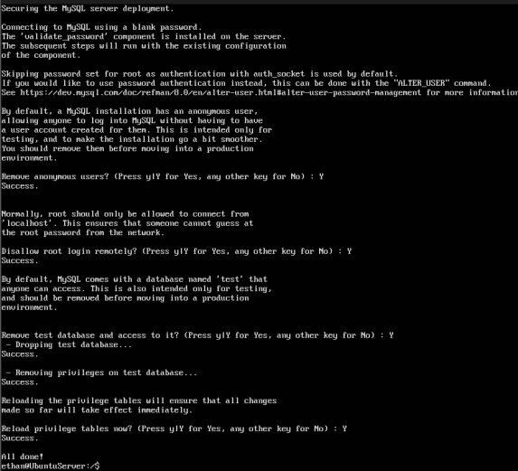
Figure 11 — mysql_secure_installation output showing all security steps completed
Database and User Creation
A dedicated database and user were created specifically for WordPress

CREATE DATABASE wordpress_db;
CREATE USER 'wp_user'@'localhost' IDENTIFIED BY 'password';
GRANT ALL PRIVILEGES ON wordpress_db.* TO 'wp_user'@'localhost';
FLUSH PRIVILEGES;
The FLUSH PRIVILEGES command forces MySQL to reload its grant tables, ensuring the new permissions are applied immediately without requiring a service restart.

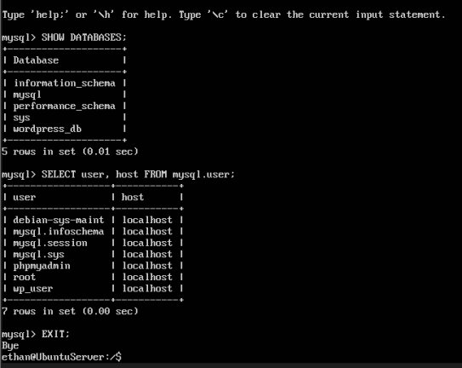
Figure 12 — Confirmation of wordpress_db creation and wp_user with correct privileges
Part 9: Installing and Securing phpMyAdmin
phpMyAdmin is a web-based graphical interface for managing MySQL databases. It allows administrators to create and modify databases, run SQL queries, manage users, and import or export data all from a browser, without needing direct command-line access to MySQL.
Because phpMyAdmin was installed to /usr/share/phpmyadmin rather than the virtual host document.

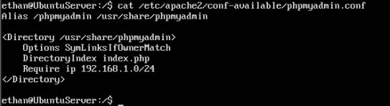
Figure 13 — phpMyAdmin Apache config file with IP-based access restriction

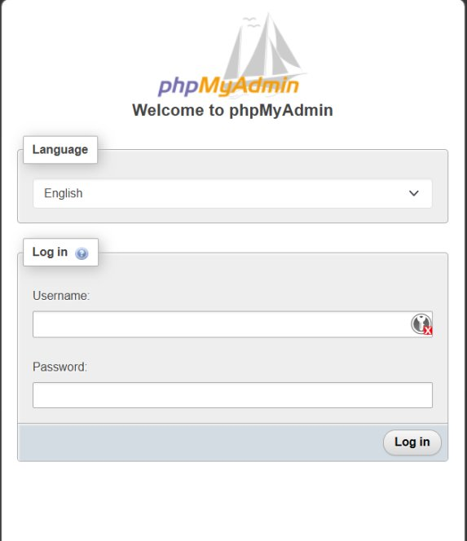
Figure 14 — phpMyAdmin login page accessible at 192.168.1.190/phpmyadmin

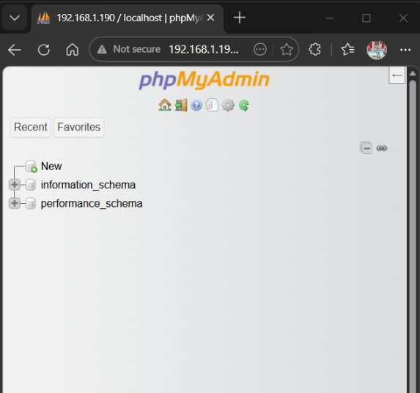
Figure 15 — phpMyAdmin dashboard after successful login showing databases
Part 10: Installing and Securing WordPress
It provides a full web publishing platform with themes, plugins, and a user-friendly administration dashboard. Installing WordPress on the configured LAMP stack (Linux, Apache, MySQL, PHP) brings together every component set up in the previous parts.
WordPress was downloaded directly from the official source, extracted, and moved into the cyberskell.com web root directory:

wget https://wordpress.org/latest.tar.gz
tar -xzvf latest.tar.gz
sudo mv wordpress /var/www/cyberskell.com

The configuration file was set up by copying the sample file: sudo cp wp-config-sample.php wp-config.php, and then editing it to add the database credentials DB_NAME, DB_USER, and DB_PASSWORD matching those created in Part 8.
File Permission Hardening
If files are owned by the wrong user or have overly permissive permissions, attackers who gain access to the web server process could modify core files, install malicious plugins, or read sensitive configuration data.

sudo chown -R www-data:www-data /var/www/cyberskell.com
sudo chmod -R 755 /var/www/cyberskell.com

The chown command transfers ownership of all files to the www-data user and group, which is the user account Apache runs under on Ubuntu. This allows Apache to read and write to WordPress files as needed for uploads and updates. The chmod 755 setting grants the owner full read/write/execute permissions while giving the group and others read and execute only.

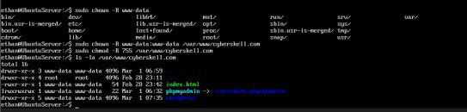
Figure 16 — File ownership and permissions applied with chown and chmod

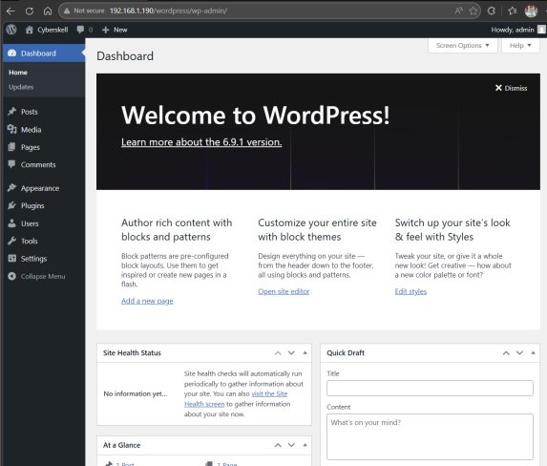
Figure 17 — WordPress administration dashboard after successful installation

Conclusion
This project successfully demonstrated the complete process of building a web and DNS server infrastructure on Ubuntu 24.04 Server from scratch. Beginning with domain registration and DNS configuration, then progressing through web server installation, SSL encryption, database setup, and web application deployment, each step built directly on the previous one to create a fully integrated server environment.
Several real-world challenges were encountered and resolved during the project. Ubuntu 24.04 changed the BIND9 service name to named, requiring changes in the programs used.
The project also reinforced several important securities like, restricting network access by IP address, applying least-privilege database permissions, hardening MySQL with the secure installation script, setting correct file ownership for web application files, and using SSL encryption for web traffic.

